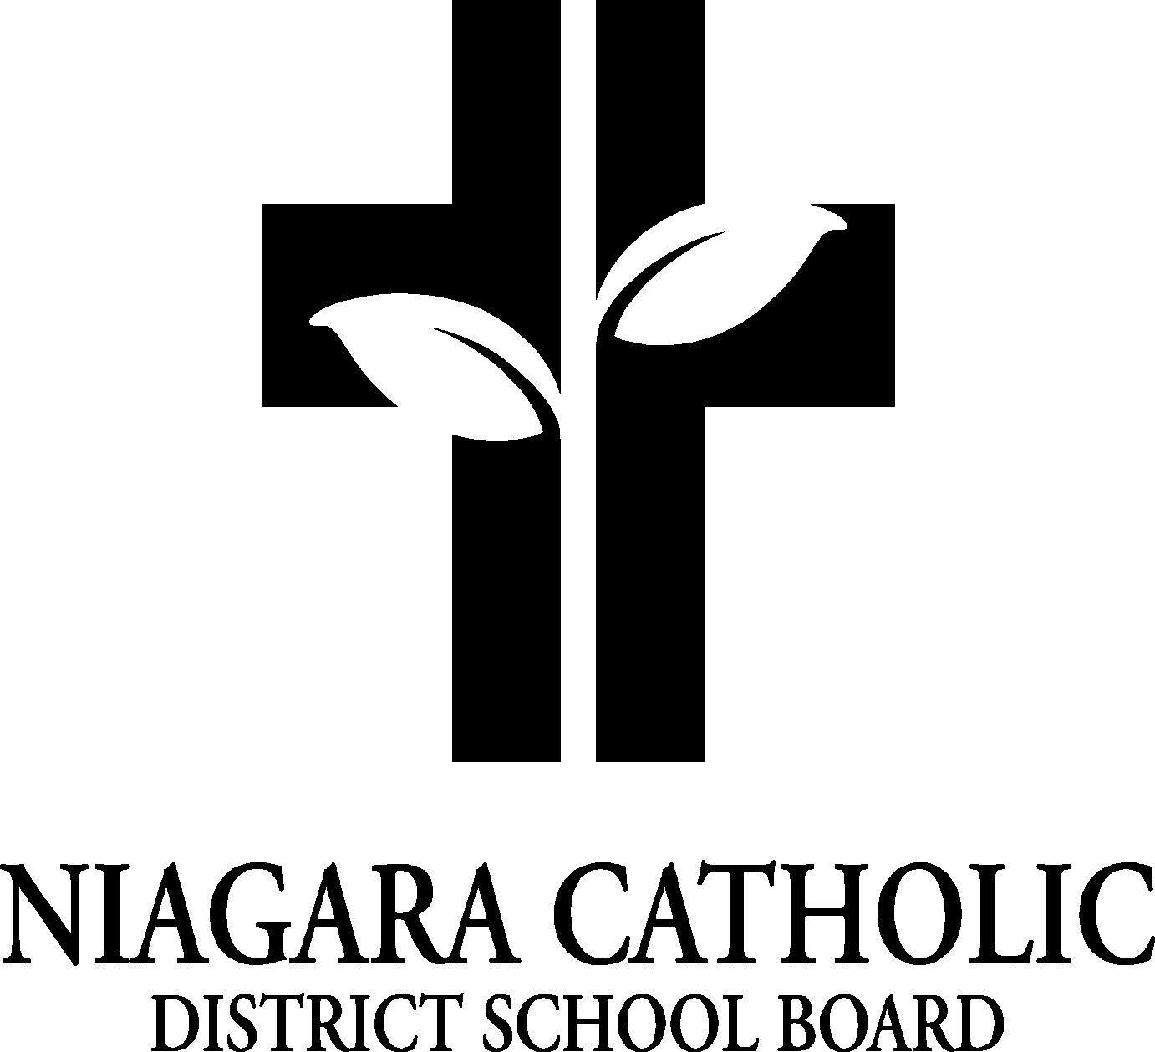

MINUTES OF THE
Monsignor Clancy and St. Charles CATHOLIC SCHOOL COUNCIL MEETING

November 2nd, 2016
Meeting held at Monsignor Clancy Catholic Elementary

Minutes of the Meeting of the Monsignor Clancy Catholic School Council, held on November 2nd, 2016
2016 at 6:30pm.
The meeting was called to order at 6:30pm by Chair of Monsignor Clancy.

A. ROUTINE MATTERS

1. Opening Prayer

The opening prayer was led by Mrs. Walsh

2. Roll Call

CATHOLIC SCHOOL COUNCIL MEMBERSHIP |  | Present | Excused | Absent
Principal/Vice-Principal  Secretary/Treasurer | Dan Trainor | 
Chair | Jen Hamm Angela Coleman | 
Co-Chair | Heather McCluckie | 
Teacher Representative | Audrey Grossi-Weber, Tanya Masales |  | x
Non-Teaching Representative | Suzie Game |  | x
Co-Principal Representative | Susy Walsh | 
Student Representative
Parish Representative | Patti McGinnis |  | x
OAPCE Representative | Sonia Mullins | 
PARENT REPRESENTATIVES
Christine Parlatore |  |  | x
Laurie Hebert |  | 
Angie Cotroneo |  |  | 
Sonya Mullins |  | 
Jennifer Hamm |  | 
Marsha Kilby-Coppola |  |  | x
Rosie Gowsell Pattison
Danya Continelli |  | 
Cassandra Rouillard |  | 
Julie Ridolfo |  |  |  | 
Mindy Coplen |  | 
Rosanne French |  | 
Marci Morandin |  | 
Angela Coleman |  | 
Heather McCluckie |  | 
Heather Sartor |  |  |  | 
Ashley Serravalle |  |  |  | 
Kendra DeGasperis |  |  |  | 

3. Approval of the Agenda

Moved by Sonia Mullins
Seconded by Laurie Hebert
THAT the Monsignor Clancy Catholic School Council approve the Agenda of the Monsignor Clancy Catholic School Council Meeting of November 2nd, 2016.
CARRIED

4. Disclosure of Interest

No disclosure of interest shared

5. Approval of Minutes of the Monsignor Clancy Catholic School Council Meeting of September 13th, 2016

Moved by Sonia Mullins
Seconded by Cassandra Rouillard
THAT Monsignor Clancy Catholic School Council approves the Minutes of the Monsignor Clancy Catholic School Council Meeting of September 13th, 2016 as presented.
CARRIED

- PRESENTATIONS
Mr. Trainor and Mrs. Walsh reviewed the policies

- CHAIR’S REPORT
Communication/Mail –Jen Hamm received an email from a guest speaker and will keep on file. Lunch lady and pita pit both sent information for hot lunch programs.
Family BBQ –everyone thought it went very well. There was less wasted this year. Adding the entertainment there was a benefit – should do the same next year.
- PRINCIPAL’S REPORT
- Niagara Catholic Parent Involvement Committee (NCPIC) Report
Shawna Daley inquiry to parents of what you want NCPIC to do for CSC – suggestion hosting a light dinner, child care and vendor displays for fundraising and Mental Health supports
- Special Education Advisory Committee (SEAC) Report
-Nil
- Thorold Santa Claus parade: discussion on having a parent committee to plan an entry for both schools for the parade. Members felt our students are well represented in other groups at the parade. Members were not inclined to take on the work of putting an entry into the parade. Members agreed to pass for this year.
- Photographer for 2017-18 – D.Trainor suggested that we book three photographers to present to CSC this school year. Members felt that most people are happy with LifeTouch and that we can continue with them until parents are inquiring about a change in provider.
- Poinsettia orders: Danya Continelli and Suzie Game to sort on 29th at Monsignor Clancy and Mme Y., to sort at St.Charles.
- Big Box Fundraiser (St.Charles) 221 were sent out – only 7 returned back so far – due Nov. 7th then the order is placed – school cash online is being used already – kids are very excited by the prizes attached to the fundraiser Dance-a-thon on February 1st 2017 (Monsignor Clancy)
- Financial Report

St Charles sitting about $3500.00 in account. School needs to keep a balance of $4000 in playground account. Repair bill for this year was $1021.60. This has been paid.
Rosanne French shared the tradition of CSC annual Christmas book purchase. Rosanne willing to buy the books, requires help sorting and organizing class sets. Rosanne will buy and then email CSC to set up organizing event. Books to go home with children on Tuesday December 20, 2016.

- OAPCE REPORTS
No reports to be shared

- STAFF REPORTS

Nil

- AGENDA ITEMS-DISCUSSION FOR FUTURE MEETINGS
- Pro Grant

- NEXT MEETING
January 12th 2017 at 6:00 at St. Charles Catholic Elementary

- ADJOURNMENT
Moved by Laurie Hebert
Seconded by Sonia Mullins
THAT the November 2nd, 2016 meeting of the Monsignor Clancy Catholic School Council be adjourned.
CARRIED

This meeting was adjourned at 6:55 PM.

- CLOSING PRAYER was led by Mrs. Walsh.

